Instructions for the creation of your very own perfect menu on taste.com
Step 1: Type into your URL bar at the top of your internet home page www.taste.com.au
** Before you go any further on the website you will need to become a member and register. To do so you will need to have an e-mail account of some sort **
Here is how to register:
Step 2: On the right hand side of the page you should be on is a tab which says “member login”, click on that. Follow the link that will appear that says Join Taste.com.au.
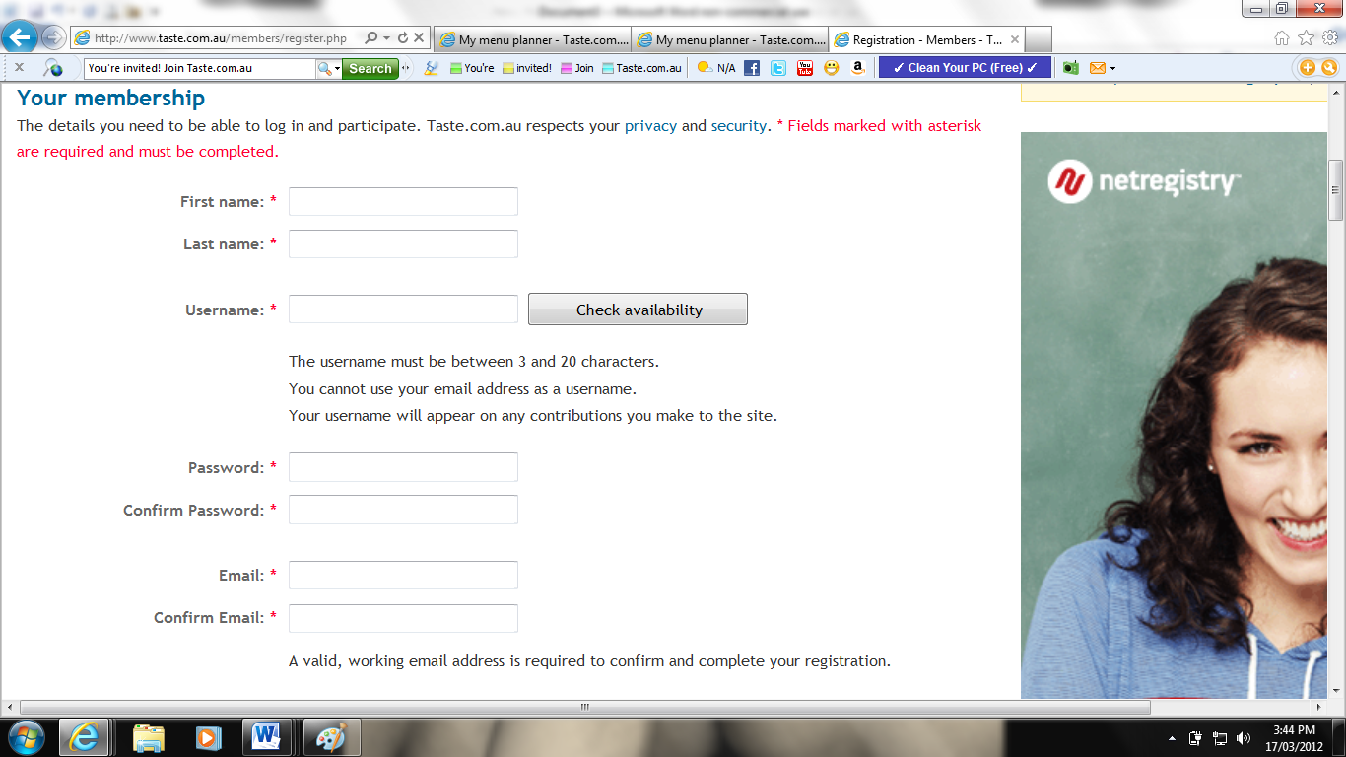
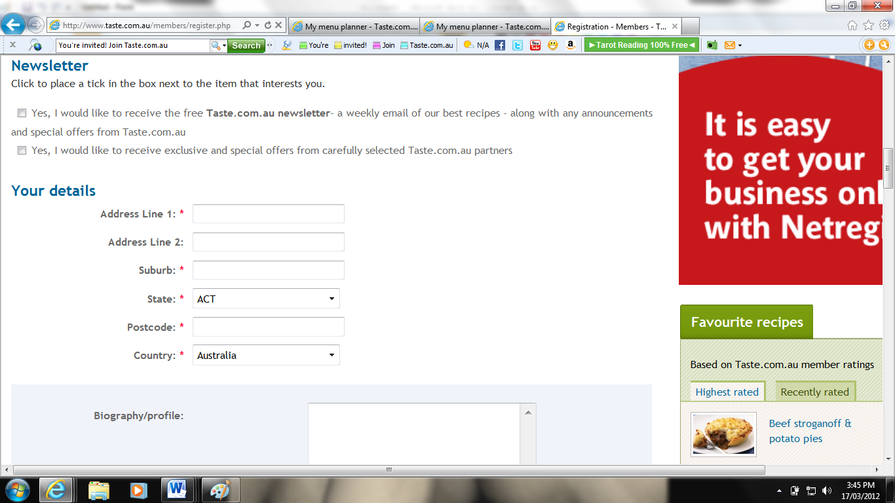
Step 3: Follow the prompts necessary for creating your account. (Begin at first name and conclude at submit)
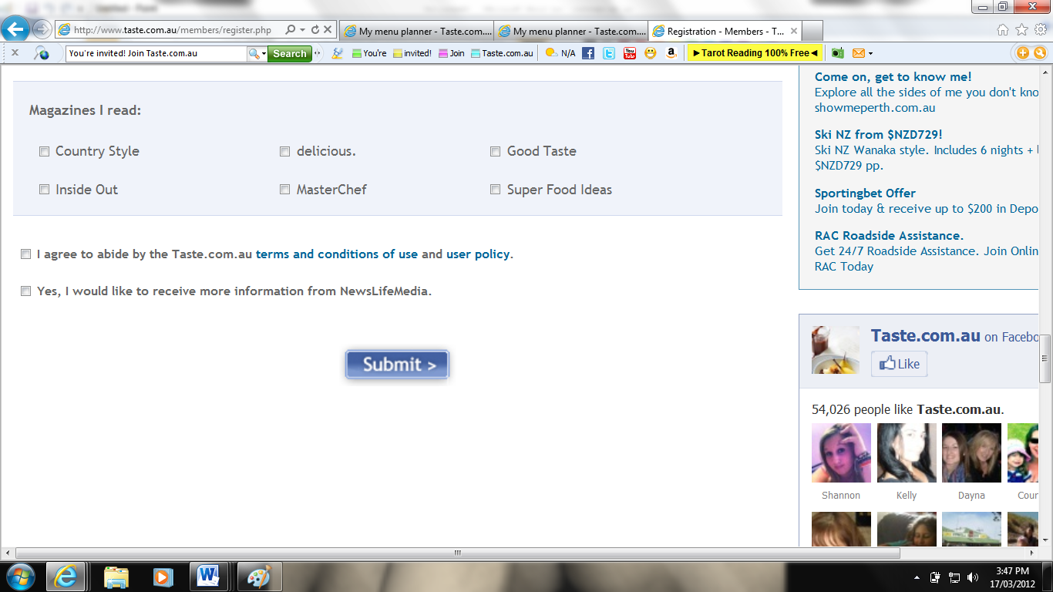
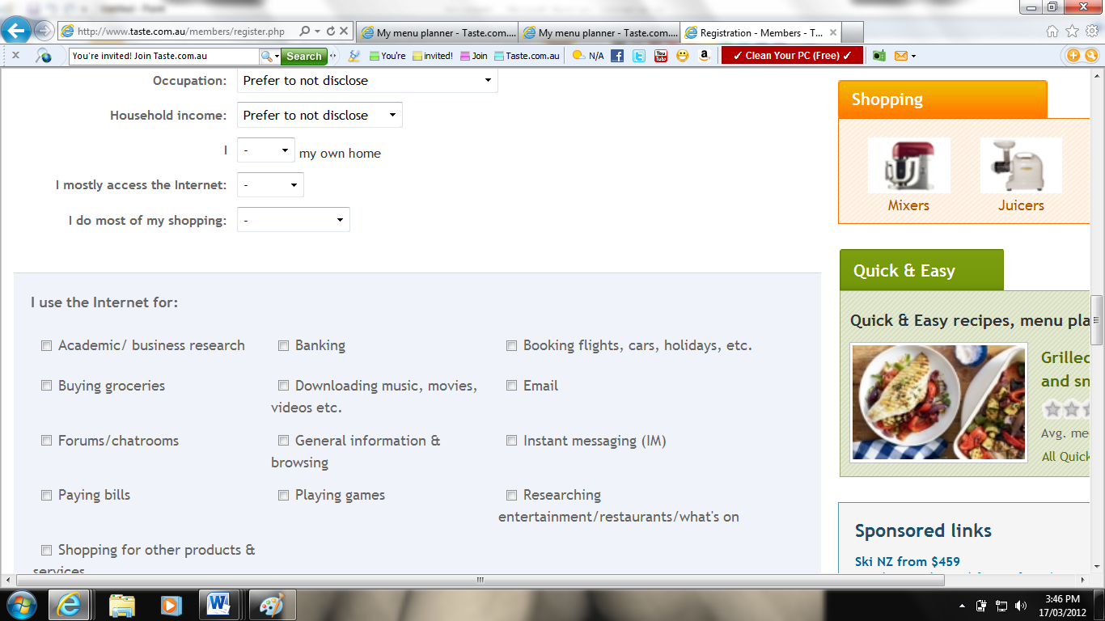
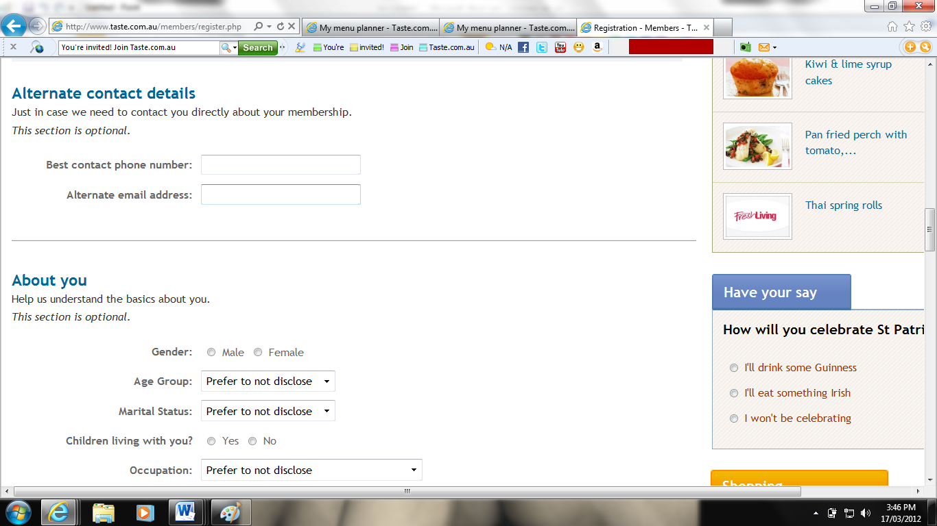
Once you have submitted your details, it means you are a member now, yay.
How to create your own menu:
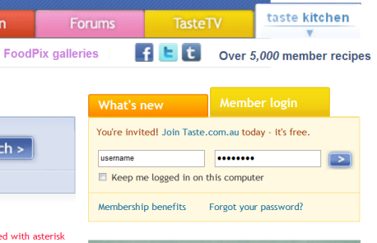
Step 4: Now scroll back up to the top of your page and fill in the username and the password you had just created in the icon that looks like this:

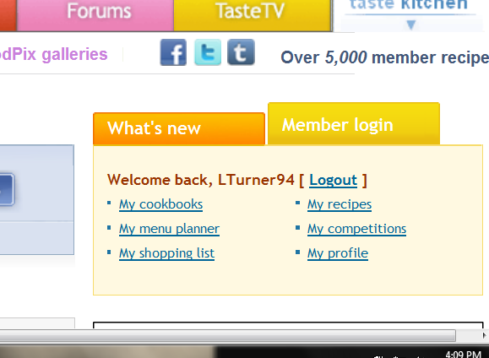
Step 5: Once you have successfully logged in it will bring you to a new page, in the top right hand corner of that page you will be presented with 6 different links, select the link that says “my menu planner”

Step 6: After you have clicked on that link it will take you to another new page. Click on the green icon that says “create a new menu plan”
- Enter in the title of your function or what you will call your menu
- Enter in the description of the function or menu
- Correct the date and time of your function that has been defaulted for you
- Select ‘save menu plan’
Step 7: Scroll down on the webpage; you will see the widgets that are titled: Entrée, Main, Dessert and Beverages. For each course an icon appears on the right hand side. Select the icon for the entrée’s first.
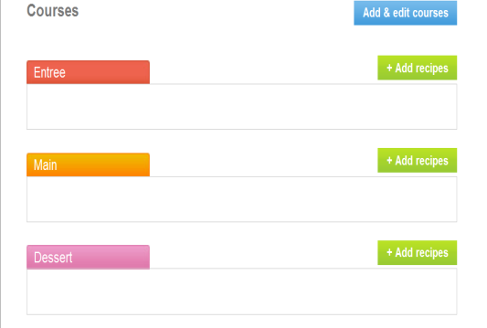

Step 8: Another new page will appear that has a search engine for the foods you are looking for.
- Enter in the food you’re looking for. E.g. Nibbles.
- Click on the search sign on the end of the search bar
- A list of numerous foods will appear
- For the foods you’re interested in, click ‘add to menu plan’
- You can choose as much food you want and change the food you’re searching for as many times as you want.
- Once you have finished selecting the foods you want, click ‘done’ at the top of the page.
**Clicking done will take you back to the previous page where your courses are. FOLLOW STEP 7 + 8 TO COMPLETE YOUR MAINS, DESSERT AND BEVERAGES**
Your menu is now finished, share with your friends.

